Class Design

# Create Initial Design Classes

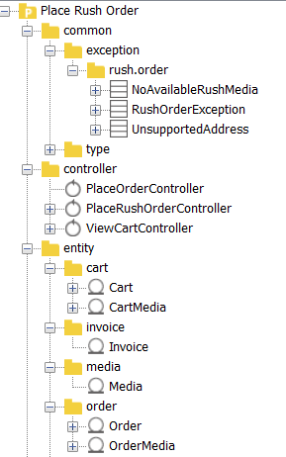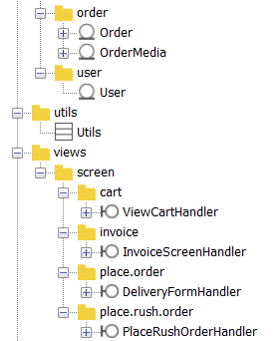

# Define Relationships Between Classes

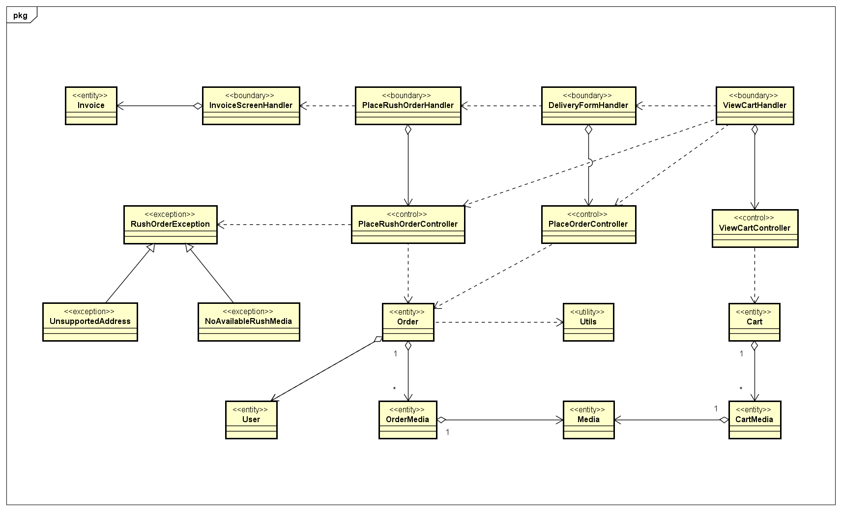

# Class Design

## Class “PlaceRushOrderHandler”

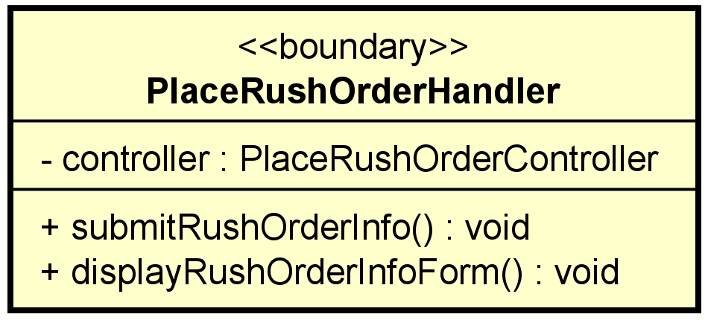

**Attribute**

|  |  |  |  |  |
| --- | --- | --- | --- | --- |
| # | Name | Data type | Default value | Description |
| 1 | controller | PlaceRushOrderController | NULL | the screen controller |

**Operation**

|  |  |  |  |
| --- | --- | --- | --- |
| # | Name | Return type | Desciption |
| 1 | submitRushOrderInfo | void | handle user click form submit button |
| 2 | displayRushOrderInfoForm | void | rendering the rush delivery form for user to fill |

Parameter:

None

Exception:

None

**Method**

None

**State**

None

## Class “PlaceRushOrderController”

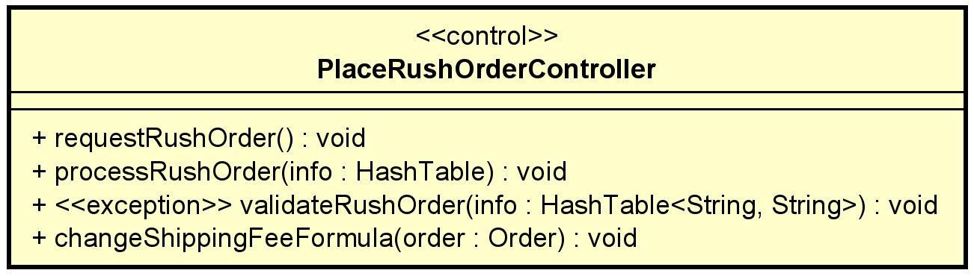

**Attribute**

None

**Operation**

|  |  |  |  |
| --- | --- | --- | --- |
| # | Name | Return type | Desciption |
| 1 | requestRushOrder | void | display form |
| 2 | processRushOrder | void | receive rush order info |
| 3 | validateRushOrder | void | check address and media supportivity and throws exception |
| 4 | changeShippingFeeFormula | void | re-calculate shipping fee with new formula |

Parameter:

info – the info in the rush delivery form

order – the order to change fee

Exception:

NoAvailableRushMedia – throw when there is no supported media for rush delivery

UnsupportedAddress – throw if the address is not supported by rush delivery

**Method**

validateRushOrder:

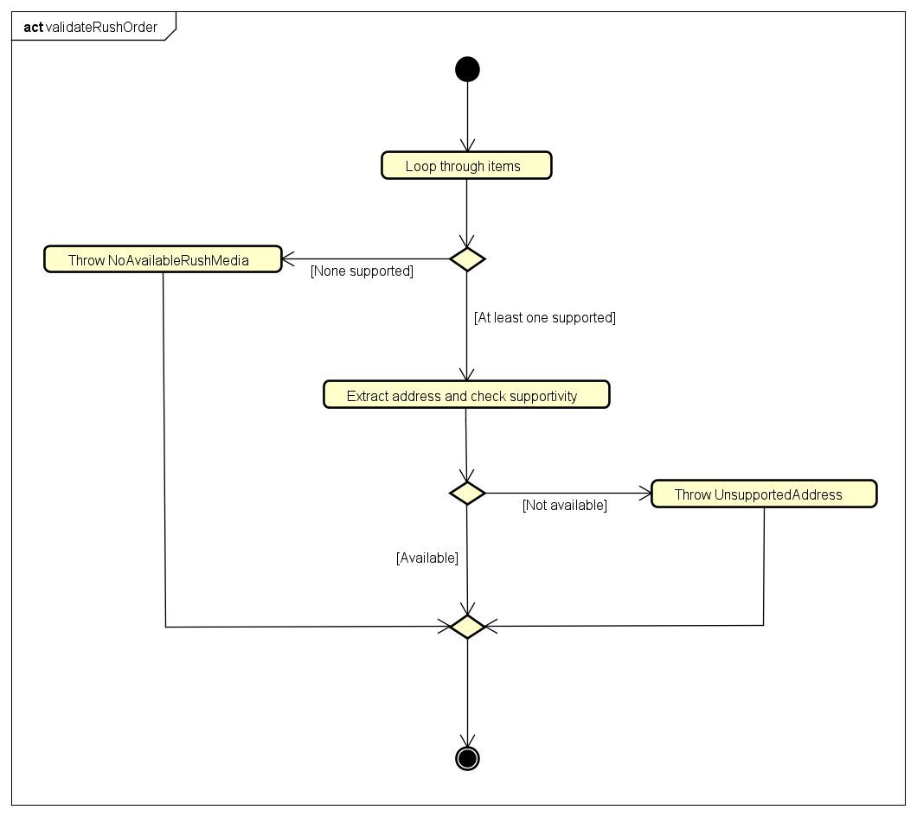

**State**

None

## Class “Order”

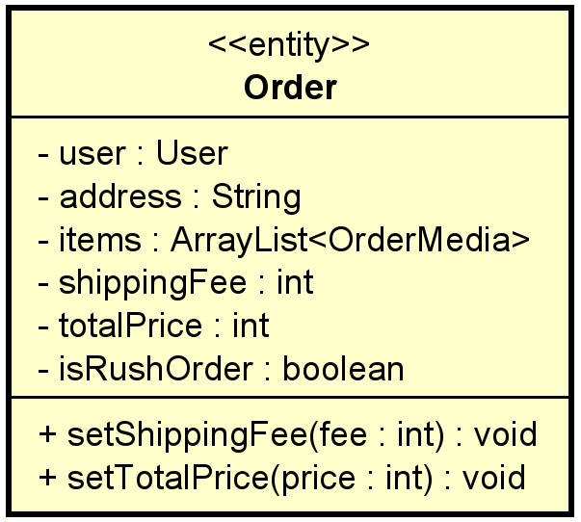

**Attribute**

|  |  |  |  |  |
| --- | --- | --- | --- | --- |
| # | Name | Data type | Default value | Description |
| 1 | user | User | NULL | order’s owner |
| 2 | address | String | NULL | shipping address |
| 3 | items | ArrayList<OrderMedia> | empty ArrayList | medias in the order |
| 4 | shippingFee | int | 0 |  |
| 5 | totalPrice | int | 0 | total price include shipping |
| 6 | isRushOrder | Boolean | false | Whether user want rush delivery |

**Operation**

|  |  |  |  |
| --- | --- | --- | --- |
| # | Name | Return type | Desciption |
| 1 | setShippingFee | void | update shipping fee |
| 2 | setTotalPrice | void | update total price |

Parameter:

fee – the new shipping fee

price – the new total price of the order

Exception:

None

**Method**

None

**State**

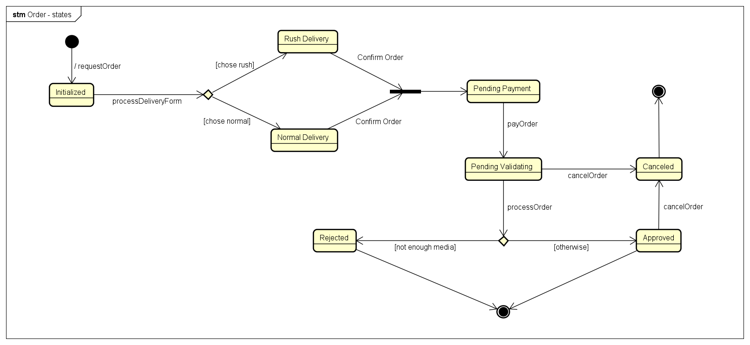

## Class “RushOrderException”

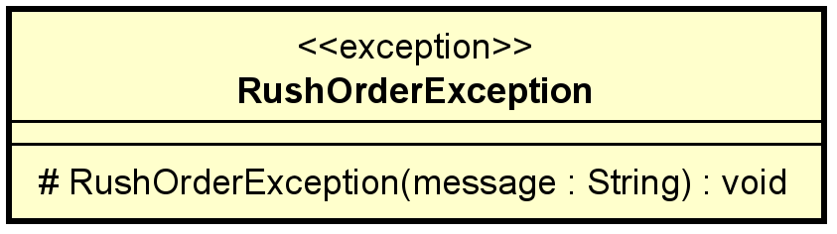

**Attribute**

None

**Operation**

|  |  |  |  |
| --- | --- | --- | --- |
| # | Name | Return type | Desciption |
| 1 | RushOrderException | void | create a new exception message for rush order |

Parameter:

None

Exception:

None

**Method**

None

**State**

None

# Class Diagram

